Assignment 3: Assignments on Flow Control and Loops

Name: Rajesh Mahendra Anerao
Sub: Python for Engineers (PFE)
Roll No.: 15
Branch: CSE-Data Science Engineering

Q 1.
Problem Statement: Program to display first n numbers
Code:
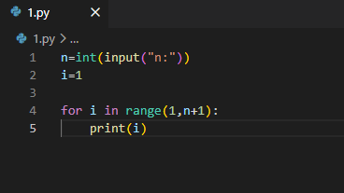
Output:
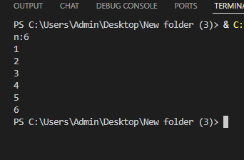
Conclusion:
This program is used to print the first n natural numbers using a loop. It helps in understanding how iteration works and how values are generated sequentially. It is a basic example of loop control structures.

Q 2.
- Problem Statement: Program to calculate factorial of a numbers
Code:
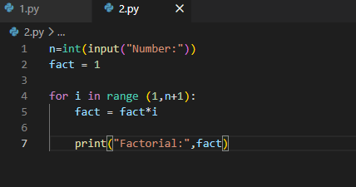
Output:
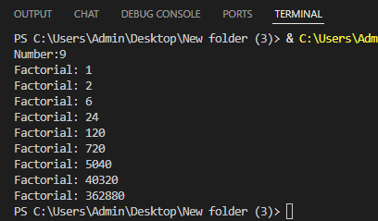
Conclusion:
This program calculates the factorial of a given number by multiplying all integers from 1 to that number. It demonstrates the use of loops or recursion and builds understanding of repeated operations. Factorial is widely used in mathematics and algorithms

Q 3.
Problem Statement: Program to display numbers in the reverse order
Code:
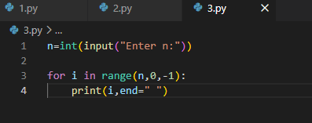
Output:
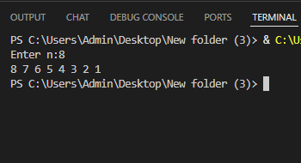
Conclusion:
This program prints numbers in reverse order, usually from n to 1. It helps in understanding decrementing loops and reverse iteration logic. It is useful in scenarios where backward traversal is required.

Q 4.
Problem Statement: Program to check if a number is prime
Code:
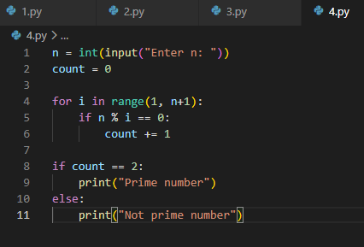

Output:
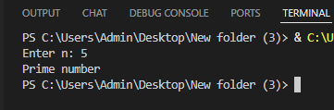
Conclusion:
This program checks whether a number is prime by verifying its divisibility. It uses conditional statements and loops to test factors. It strengthens concepts of logic building and number properties.

Q 5.
Problem statement:
Code:
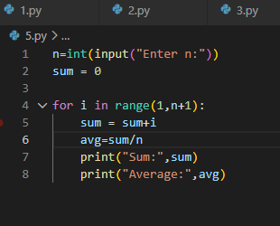
Output:
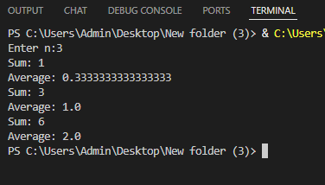
Conclusion:
This program calculates the sum of the first n natural numbers and then finds their average. It demonstrates accumulation using loops and basic arithmetic operations. It is useful for understanding data aggregation.

Q 6.
Problem Statement: Program to display first N Multiples of number
Code:
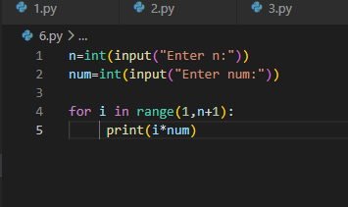
Output:
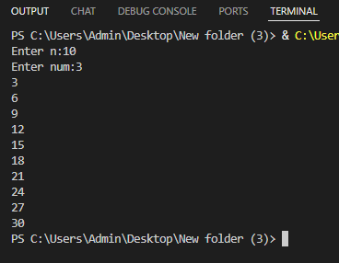
Conclusion:
This program generates and prints the first n multiples of a given number. It uses loops and multiplication operations. It helps in understanding patterns and sequences in numbers.

Q 7.
Problem Statement: Program to display first N fibbonaci numbers
Code:
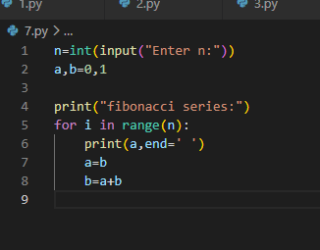
Output:
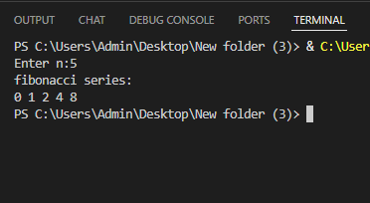
Conclusion:
This program generates the Fibonacci sequence where each number is the sum of the previous two. It helps in understanding sequence logic and variable updates. It is a common example used in programming practice.

Q 8.
Problem statement: Program to find the sum of digits of the numbers
Code:
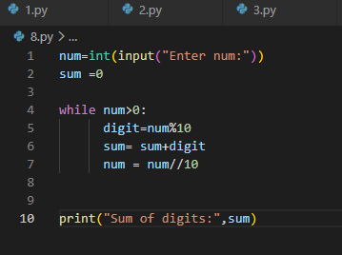
Output:
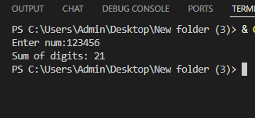
Conclusions:
This program calculates the sum of all digits of a number using modulus and division operations. It helps in understanding how to break down numbers into individual digits. It is useful in many number-based applications.

